EXP NO: 10 MBR and GPT Forensics NAME : ADHIYAN PERIYAR R P

DATE: 04/09/2025 ROLL NO : 231901002

AIM:

Learn how MBR and GPT forensics are carried out to identify attacks during the boot process.

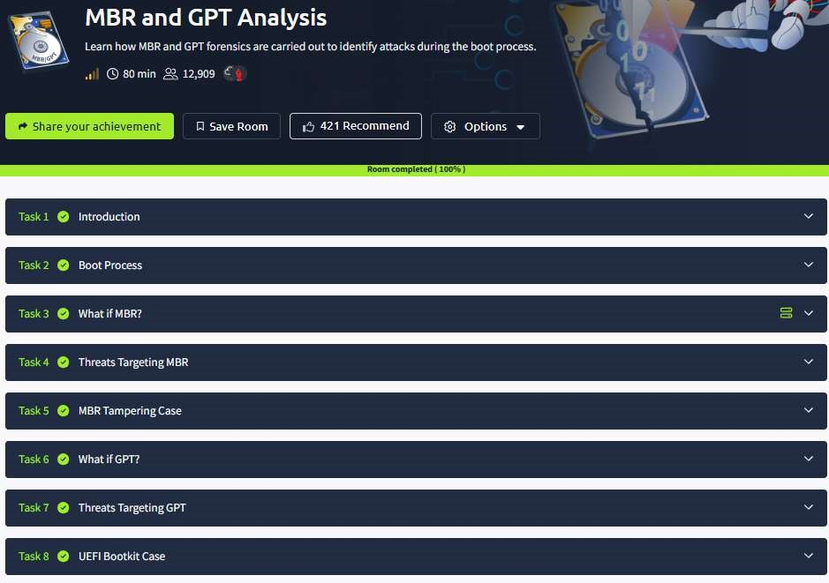

Task 1 : Introduction

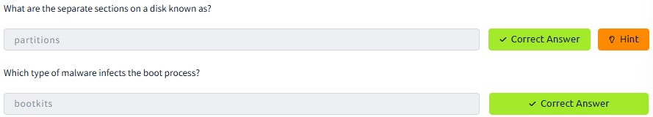

Task 2 : Boot Process

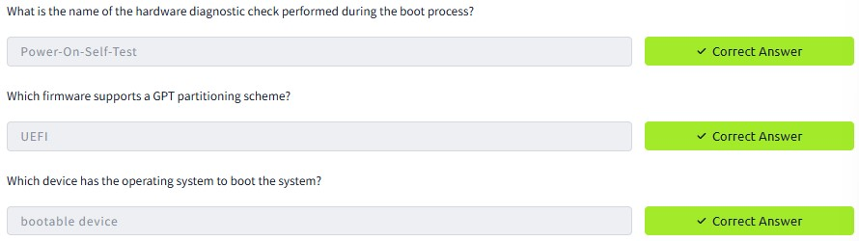

Task 3 : What if MBR?

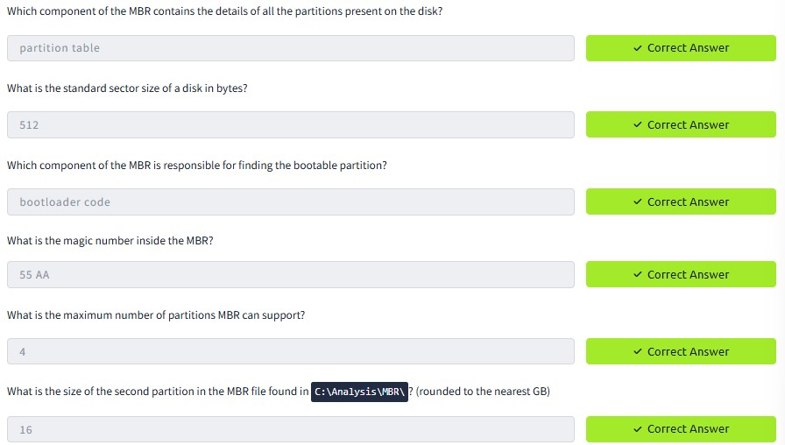

Task 4 : Threats Targeting MBR



Task 5 : MBR Tampering Case

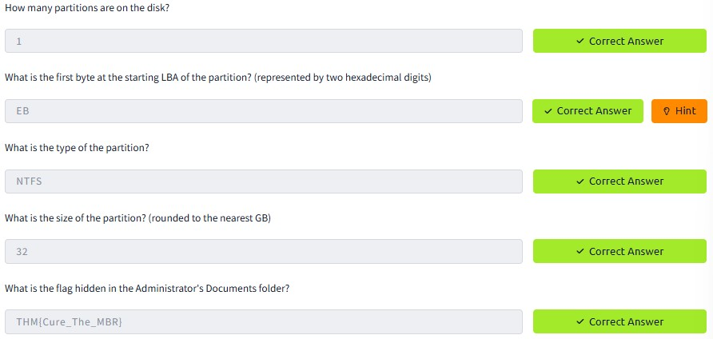

Task 6 : What if GPT?

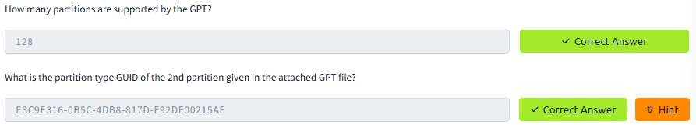

Task 7 : Threats Targeting GPT



Task 8 : UEFI Bootkit Case

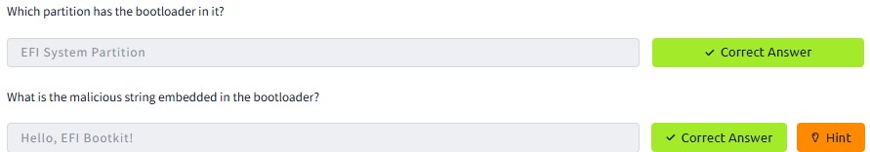

RESULT :

MBR and GPT Forensics is successfully completed in tryhackme platform.